Task 10: Create a File Locally and Push It to a GitHub Branch

Outcome
A file named practice.txt is created in the local repository, committed using Git, and pushed to the Feature-Branch branch on GitHub.

Objective
To learn how to create a file locally, track it with Git, commit the changes, and upload the commit to a remote GitHub branch.

Prerequisites
- Git is installed on your computer.
- The GitHub repository has already been cloned to your computer.
- The repository folder is ~/desktop/new-repository.
- The Feature-Branch branch exists locally or on GitHub.
- You have permission to push changes to the GitHub repository.

Step-by-Step Implementation

Step 1: Open the local repository
Open Git Bash and navigate to the repository folder.
cd ~/desktop/new-repository

Step 2: Switch to the feature branch
Switch to Feature-Branch. If you are already on this branch, Git will indicate that you are already there.
git switch Feature-Branch

Step 3: Create a new file
Create a file named practice.txt in the repository folder.
touch practice.txt

Step 4: Add content to the file
Write a sample line into the file.
echo "This is my first local file" > practice.txt

Step 5: Verify the file content
Display the contents of practice.txt.
cat practice.txt
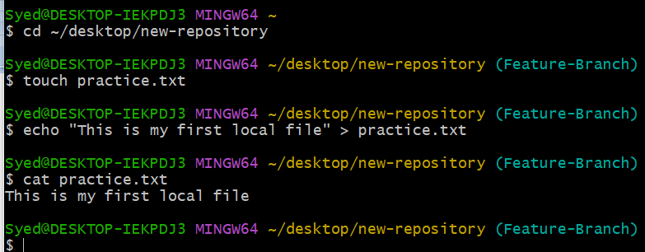

Step 6: Check Git status
Check whether Git detects the new file. It should appear as an untracked file before staging.
git status

Step 7: Stage the file
Add the file to the staging area so it can be included in a commit.
git add practice.txt

Step 8: Commit the file
Save the staged change in the local Git repository with a descriptive message.
git commit -m "Add practice text file"
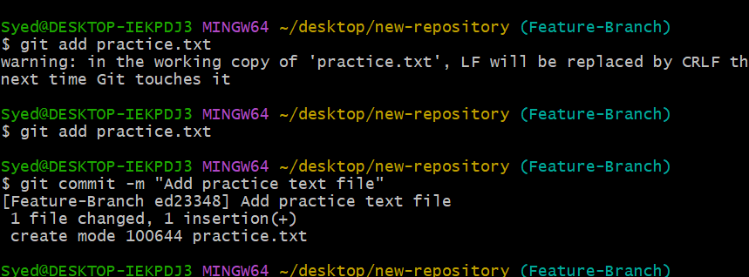

Step 9: Push the branch to GitHub
Upload the committed changes to the remote Feature-Branch branch.
git push -u origin Feature-Branch

Step 10: Verify on GitHub
Open your GitHub repository in a browser. Select Feature-Branch from the branch dropdown and confirm that practice.txt appears in the file list.

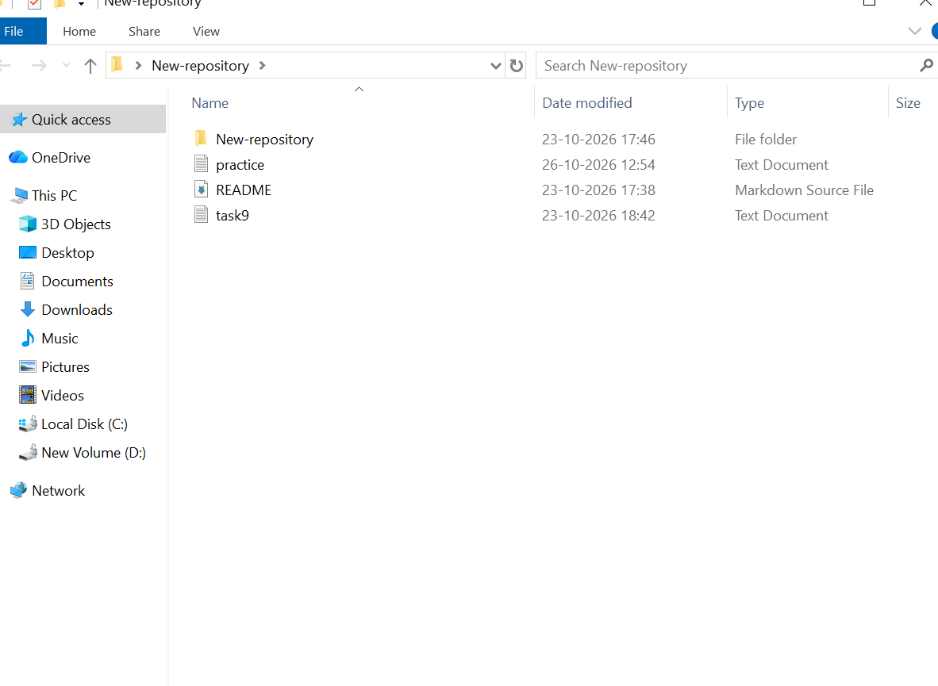

All Commands Together
cd ~/desktop/new-repository
git switch Feature-Branch
touch practice.txt
echo "This is my first local file" > practice.txt
git status
git add practice.txt
git commit -m "Add practice text file"
git push -u origin Feature-Branch

Troubleshooting Notes
- If Git says “nothing to commit,” check whether the file was already committed or whether its content has changed.
- If the push fails, check the remote URL with: git remote -v
- If Feature-Branch does not exist locally, fetch the remote branches first with: git fetch origin, then check available branches with: git branch -a.
- If Git requests authentication, sign in or configure the authentication method required for your GitHub account.

Expected Result
The practice.txt file is created on your computer, committed to Git, and successfully pushed to the Feature-Branch branch on GitHub.

